TASK 1.1 Apache Kafka Core Concepts

Apache Kafka is a distributed event-streaming platform used to exchange, store, and process data in real time. It allows different applications and services to communicate efficiently through messages. Kafka is widely used in modern systems because it is scalable, reliable, and fault-tolerant. Understanding its core concepts is essential for building event-driven applications.

TOPIC
A Topic is a logical channel used to store and organize messages in Kafka. Producers send messages to a topic, and consumers read messages from it. Topics help separate different types of data and make message management easier. For example, an e-commerce application may have topics such as orders, payments, and inventory to store different events.

PARTITION
A Partition is a subdivision of a topic that allows Kafka to distribute data across multiple servers and process messages in parallel. Each partition stores messages in the order they are received. Using multiple partitions improves the scalability and performance of Kafka applications.

OFFSET
An Offset is a unique sequential number assigned to each message within a partition. It indicates the position of a message and helps consumers track which messages have already been processed. Offsets allow consumers to continue reading messages from the correct location even after a restart or failure.

BROCKER
A Broker is a Kafka server that stores messages and handles communication between producers and consumers. A Kafka cluster can consist of one or more brokers working together. Brokers are responsible for managing topics, partitions, and message storage.

REPLICATION FACTOR
The Replication Factor specifies the number of copies of a partition that Kafka maintains across different brokers. Replication improves fault tolerance by ensuring that data remains available even if a broker fails. A higher replication factor provides better reliability and data protection.

ISR
ISR stands for In-Sync Replicas. These are replicas that are fully synchronized with the leader partition. Kafka uses the ISR list to maintain data consistency and availability. If the leader broker fails, one of the replicas from the ISR list can be selected as the new leader.

PRODUCER
A Producer is an application that sends messages to Kafka topics. Producers generate data and publish it to Kafka for further processing. For example, an online shopping application can act as a producer by sending order details to an orders topic.

CONSUMER
A Consumer is an application that reads and processes messages from Kafka topics. Consumers subscribe to topics and receive messages as they become available. For example, an inventory service may consume order messages to update product stock information.

CONSUMER GROUP
A Consumer Group is a collection of consumers working together to process messages from a topic. Kafka distributes partitions among consumers in the same group, enabling parallel processing and load balancing. This improves the performance and scalability of message consumption.

ZOOKEEPER AND KRAFT
ZooKeeper was used in older Kafka versions for cluster coordination, metadata management, and leader election. It helped Kafka maintain information about brokers and partitions. However, managing ZooKeeper added complexity to Kafka deployments.
KRaft (Kafka Raft Metadata Mode) is the modern replacement for ZooKeeper. It allows Kafka to manage cluster metadata internally without requiring an external service. KRaft simplifies deployment, improves scalability, and is the recommended mode for Kafka 3.x and later versions.
Conclusion
Apache Kafka provides a powerful platform for real-time data streaming and communication between applications. Concepts such as topics, partitions, offsets, producers, consumers, and replication work together to ensure reliable and scalable message processing. Understanding these concepts forms the foundation for building event-driven and distributed applications using Kafka.

TASK 1.2 – KAFKA CLUSTER SETUP
A single-node Kafka environment was deployed using Docker Compose. The Kafka container was started successfully and made available for further operations such as topic creation, message publishing, and message consumption.
docker compose up -d
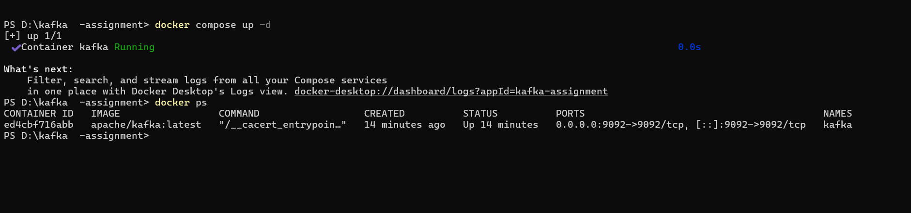.

KAFKA BROKER STATUS CHECK
After starting the container, the Kafka broker status was verified using Docker commands. The output confirmed that the Kafka broker was active and listening on port 9092.
docker ps

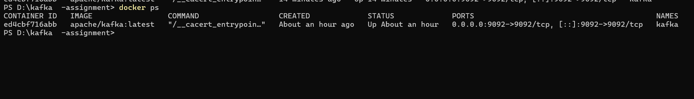

CREATING A TOPIC
A new Kafka topic named ecommerce-orders was created. The topic was configured with three partitions to support parallel processing and a replication factor of one because only a single broker was available in the current setup.
docker exec -it kafka bash

/opt/kafka/bin/kafka-topics.sh --create --topic ecommerce-orders --bootstrap-server localhost:9092 --partitions 3 --replication-factor1

The command executed successfully and the topic was created.
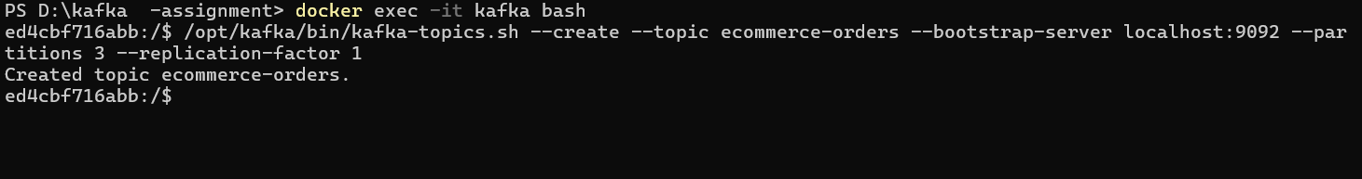

PUBLISHING MESSAGES
The Kafka console producer was launched and several sample messages were sent to the ecommerce-orders topic. These messages represent data that could be generated by an e-commerce application.
/opt/kafka/bin/kafka-console-producer.sh --topic ecommerce-orders --bootstrap-server localhost:9092
Sample messages entered:
order1
order2
order3

READING MESSAGES
To verify that the messages were stored correctly, a Kafka console consumer was started. The consumer retrieved all available messages from the beginning of the topic.
docker exec -it kafka bash

/opt/kafka/bin/kafka-console-consumer.sh --topic ecommerce-orders --from-beginning --bootstrap-server localhost:9092
The consumer successfully displayed the messages that were previously published by the producer.
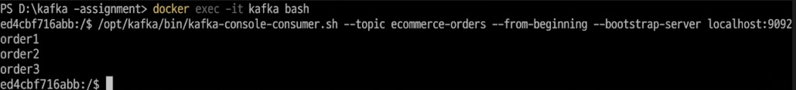

CONCLUSION
The Kafka environment was configured and tested successfully using Docker in KRaft mode. The broker was started, a topic was created, messages were published using a producer, and the same messages were retrieved using a consumer. This verified the successful operation of the Kafka messaging workflow.

TASK 1.3 – WORKING WITH KAFKA PARTITIONS

Introduction
In this task, Kafka partitioning was explored by creating a topic with multiple partitions, producing messages with different keys, and consuming data from a specific partition. This experiment helped in understanding how Kafka distributes messages internally and maintains message ordering.

Creating the Orders Topic
A topic named orders was configured in Kafka with three partitions and a replication factor of one. The topic acts as a logical channel for storing and organizing order-related messages.
Commands used:
docker exec -it kafka bash

/opt/kafka/bin/kafka-topics.sh --create --topic orders --bootstrap-server localhost:9092 --partitions 3 --replication-factor 1
The successful execution of the command confirmed that the topic was available for message exchange.
The topic named orders was successfully created and verified. The topic contains three partitions and a replication factor of one.

Publishing Key-Based Messages
To study partition allocation, messages were produced with keys. Kafka uses these keys to determine the destination partition.
Producer command:
/opt/kafka/bin/kafka-console-producer.sh --topic orders --bootstrap-server localhost:9092 --property "parse.key=true" --property "key.separator=:"

Messages sent:
user1:order101
user2:order102
user3:order103
user1:order104
user2:order105
user3:order106
user1:order107
user2:order108
user3:order109
user1:order110
The keys ensured that related messages were routed consistently to the same partition.
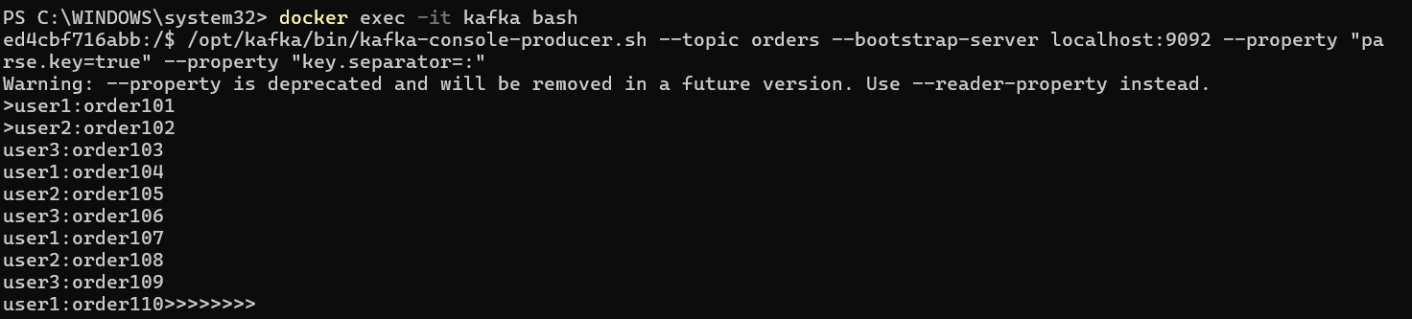

Reading Data from a Single Partition
Instead of consuming all topic data, only Partition 0 was targeted. This helped identify which messages Kafka had assigned to that partition.
Consumer command:
docker exec -it kafka bash

/opt/kafka/bin/kafka-console-consumer.sh --topic orders --partition 0 --from-beginning --bootstrap-server localhost:9092
The consumer displayed only the records available in Partition 0.
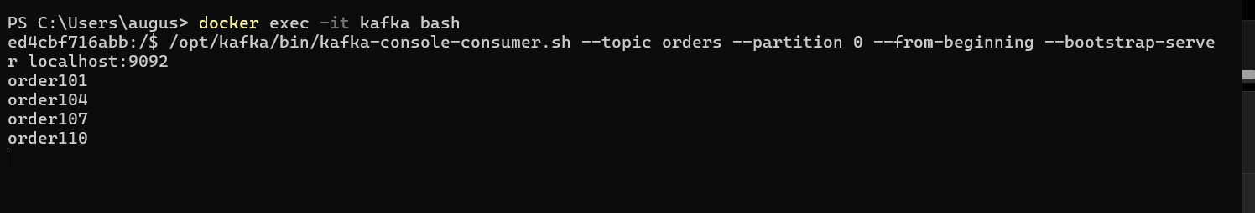

Analysis
Kafka did not place every message in the same partition. The partition selection was based on the key attached to each message. Messages with identical keys were directed to the same partition, while messages with different keys were spread across the available partitions. This behavior enables Kafka to process large volumes of data efficiently while preserving the order of related messages.

Learning Outcome
Through this activity, the partitioning feature of Kafka was successfully demonstrated. The experiment showed that Kafka automatically distributes records among partitions using message keys. It also highlighted how consumers can read data from a specific partition when required. This mechanism improves scalability, load distribution, and message organization in distributed applications.

